Boston Crimes (2015-2018)

I have chosen a dataset that assesses the crimes committed in Boston over time. The chosen dataset will assist us in analyzing a wide range of crimes that took place in Boston between 2015 and 2018. This visualization will greatly assist us in plotting down:

* The most frequent crimes in Boston.
* Their frequency in terms of days
* Drugs Analysis by District
* Incident Count by UCR Part
* Crime by UCR And Offense Group
* Crime by the Month Forecast
* Crime Proportions
* Crime by the Day of Week Latest Year

Data sets explored:

For the project, we considered quite a few datasets and shortlisted two of them.

* Dataset from Analyze Boston – Boston Police Department.
* Dataset from world cities.

Dataset selected for analysis:

* We have chosen the dataset. This dataset, which includes data from the new crime incident report system with a condensed set of fields focusing on capturing the type of incident as well as when and where it occurred, fits in perfectly with the goals of this visualization. The Boston Police Department (BPD) provides crime event reports to record the preliminary information around an occurrence to which BPD officers respond.
* With the help of the visualization, BPD officers will have access to a live dashboard that will show them crime trends over the previous four years in Boston. They can then analyze, plan, and patrol the areas using the available data.

Variables of Interest & Data cleaning:

These are the variables from our dataset which we are going to consider modelling the visualizations. We have classified the variables and cleaned them.

* INCIDENT_NUMBER
* OFFENSE_CODE
* OFFENSE_CODE_GROUP
* OFFENSE_DESCRIPTION
* DISTRICT
* REPORTING_AREA
* SHOOTING
* OCCURANCE_ON_DATA
* YEAR
* MONTH
* DAT_OF_WEEK
* HOUR
* UCR_PART
* STREET
* LAT
* LONG
* LOCATION

Python Code for Data Cleaning

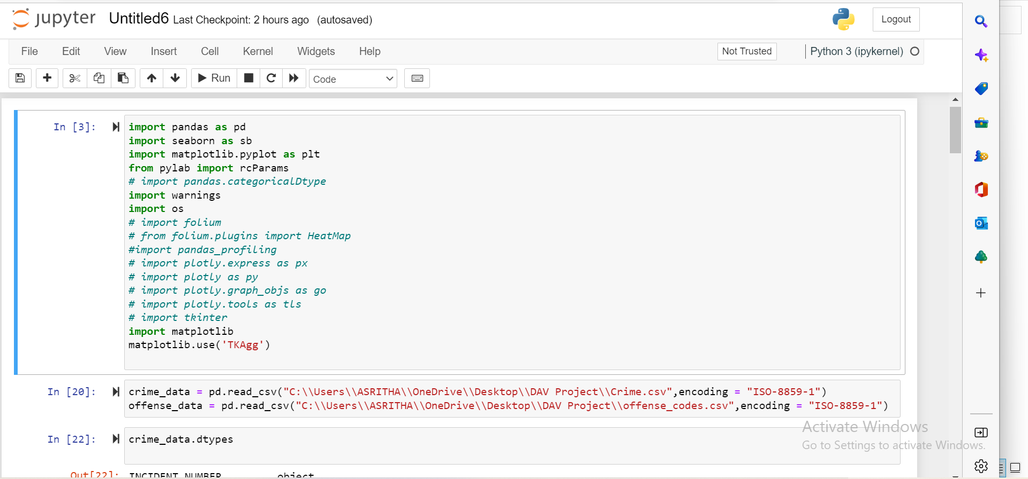

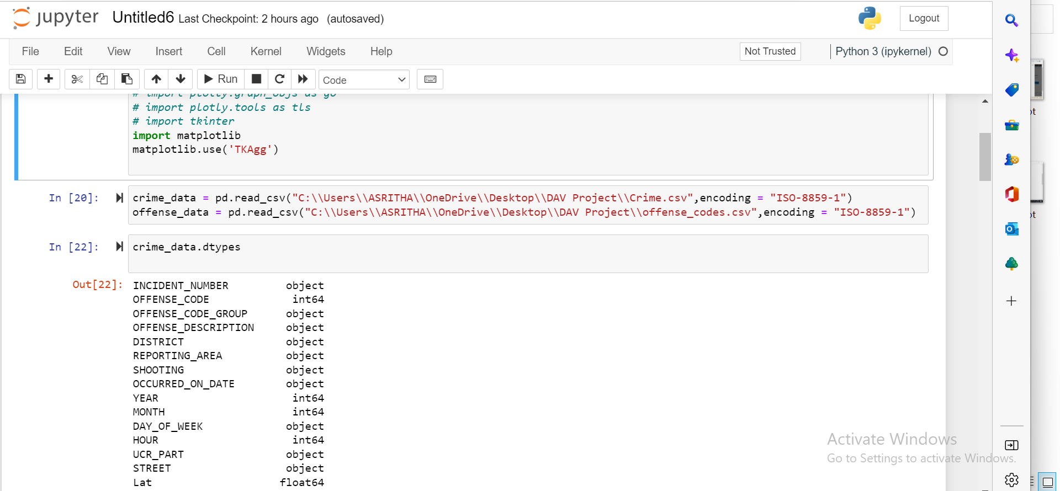

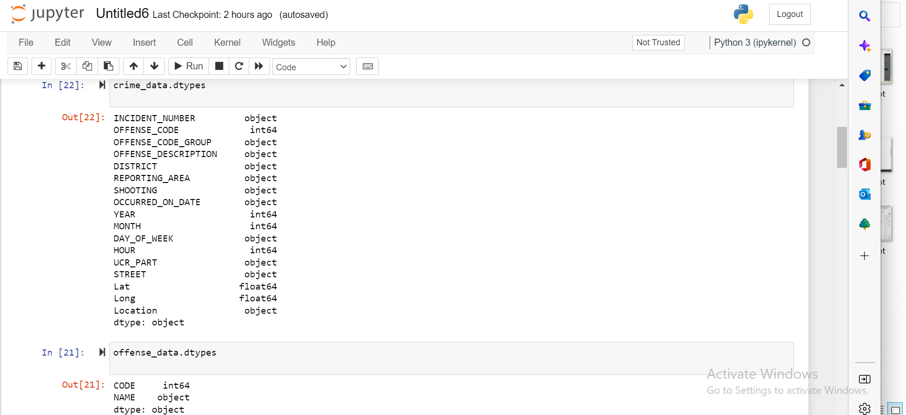

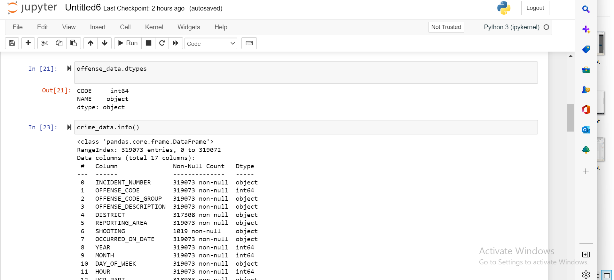

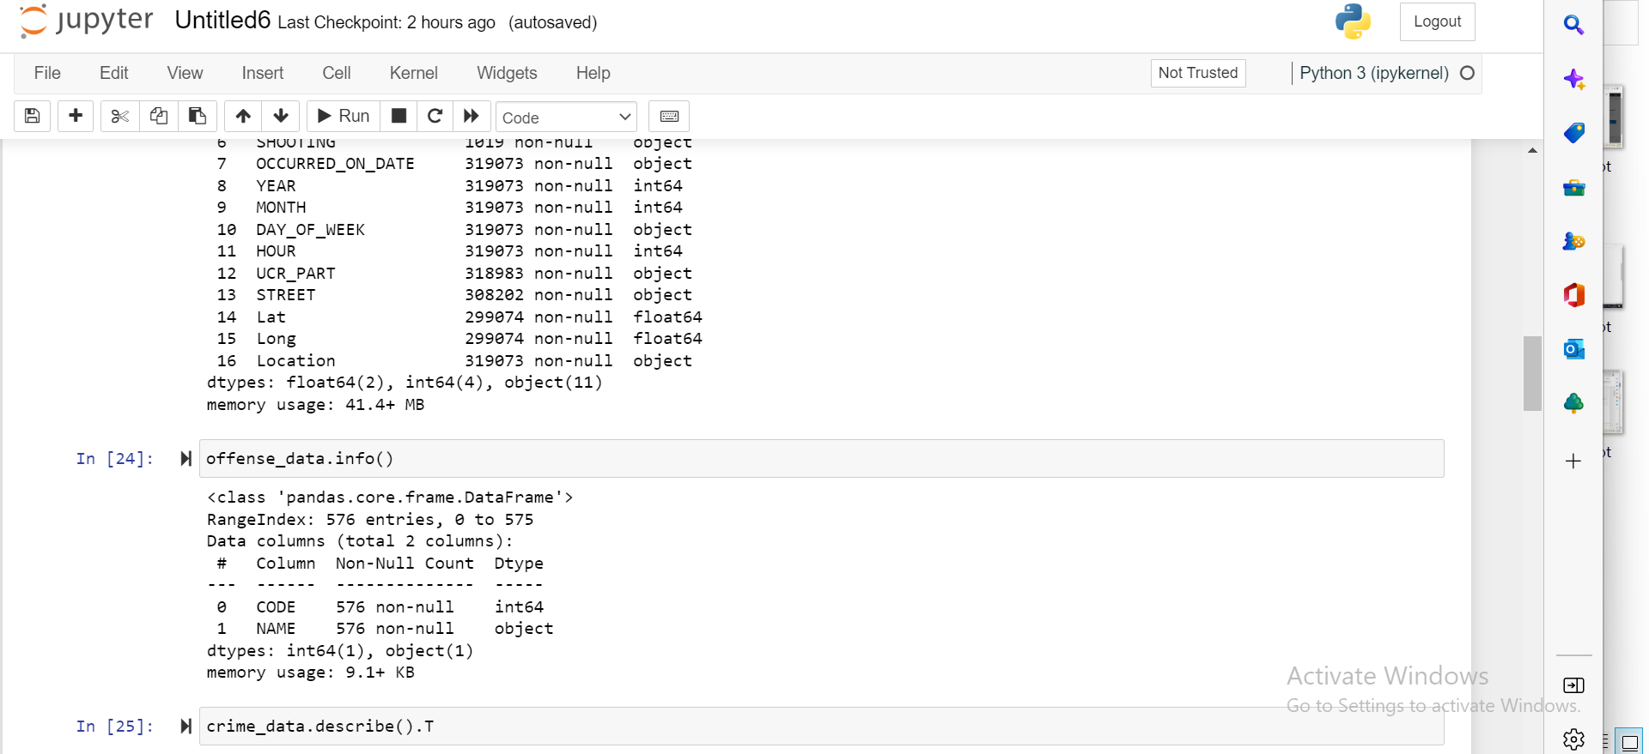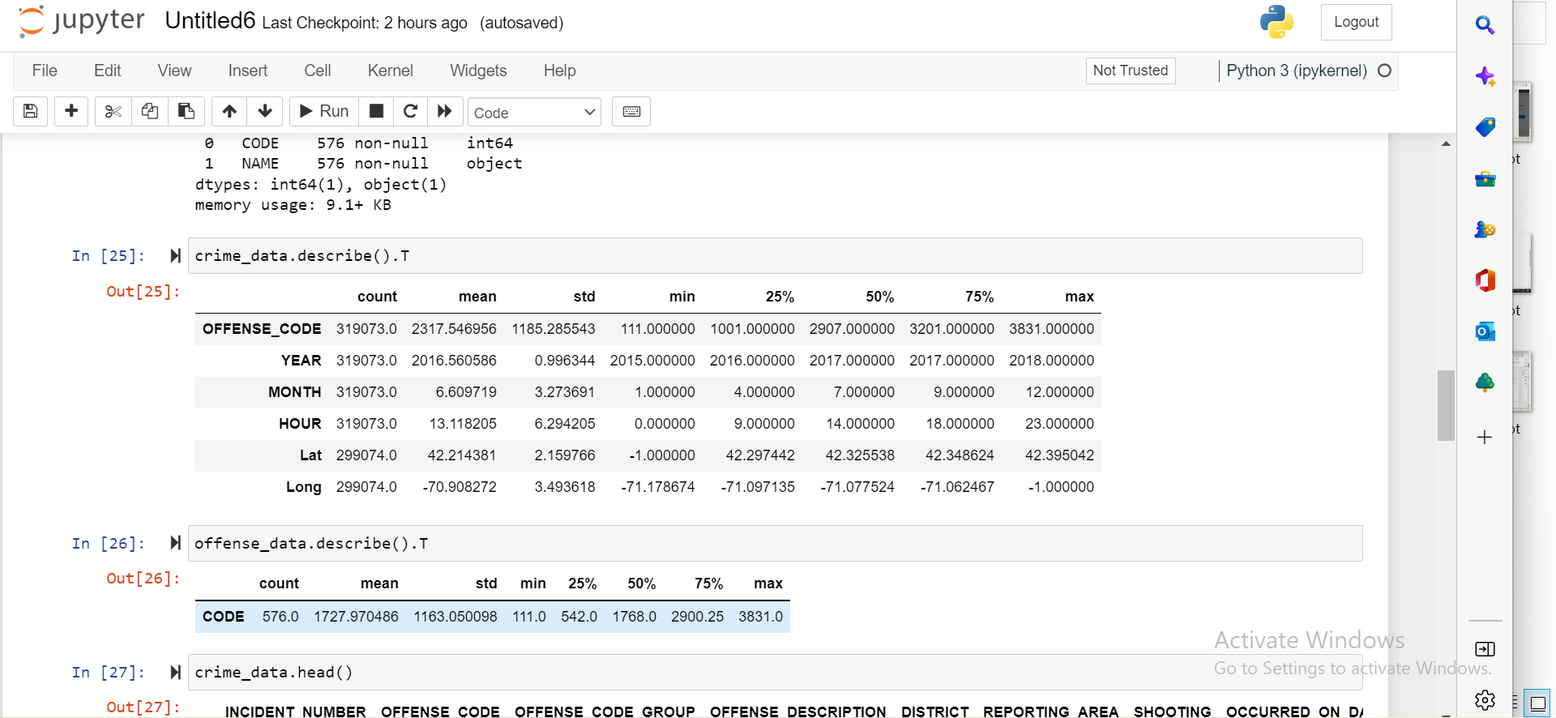

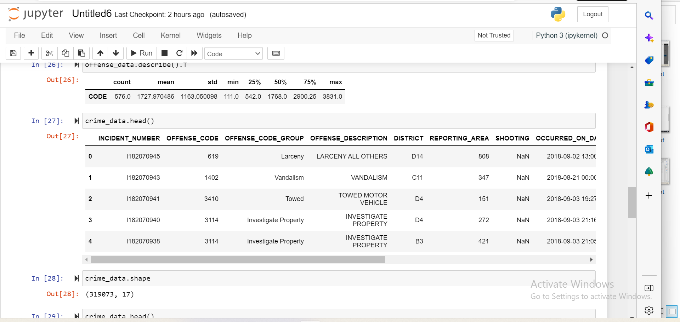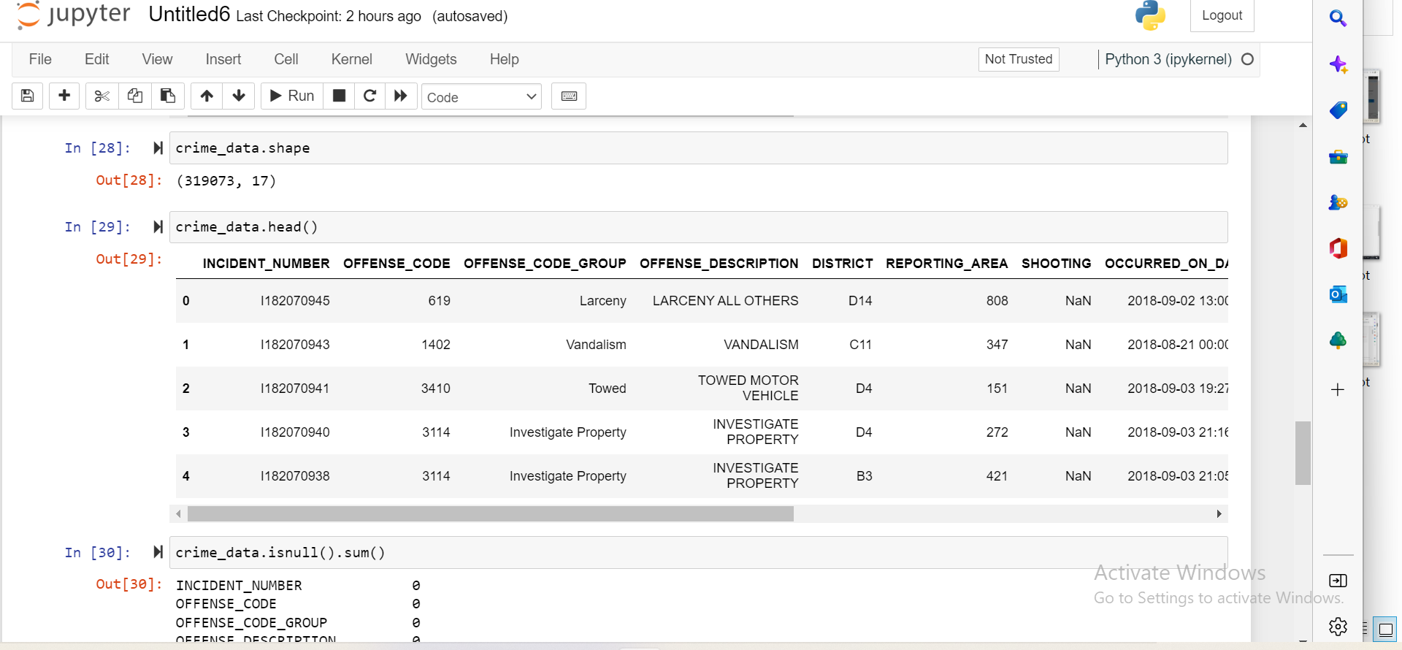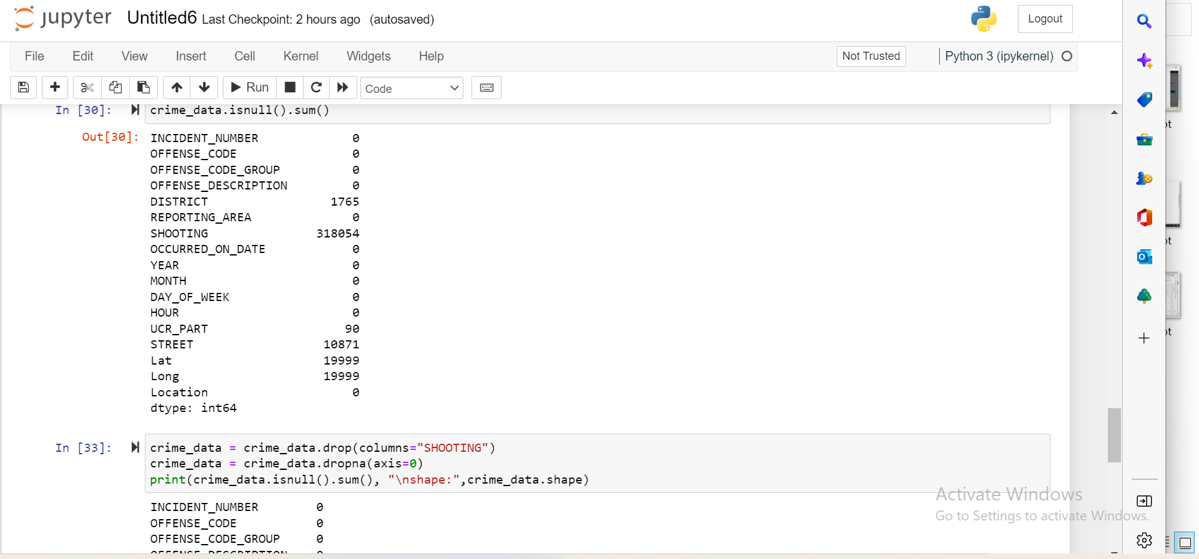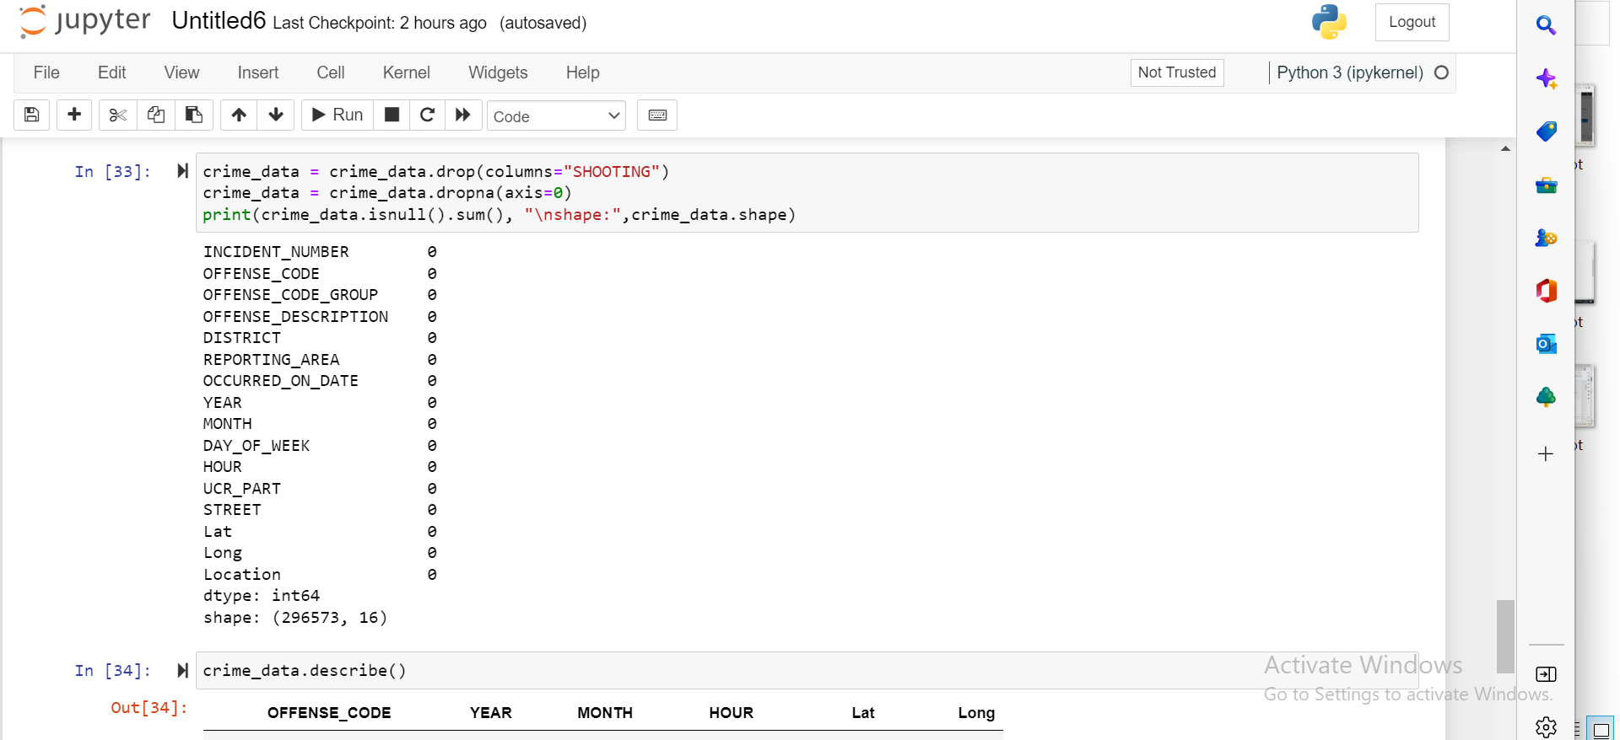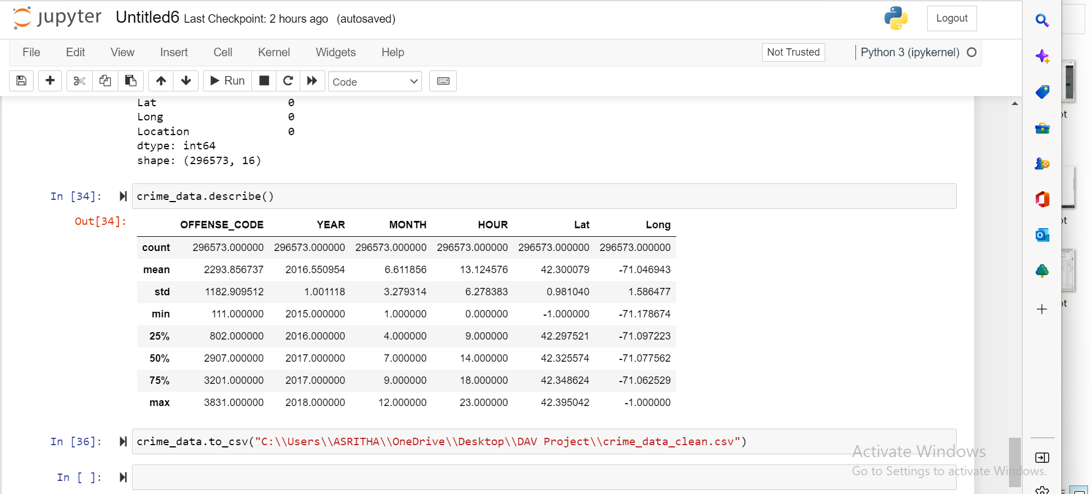

Merging Datasets

We combined the files crime.csv and offence codes.csv from the source Analyze Boston.

A district- and section-level crime classification is provided by this dataset merging, which contributes to the provision of new insights.

Visualization Analysis

*Fig 1:*

*Counts crimes in terms of weeks and Drug Analysis by District.*

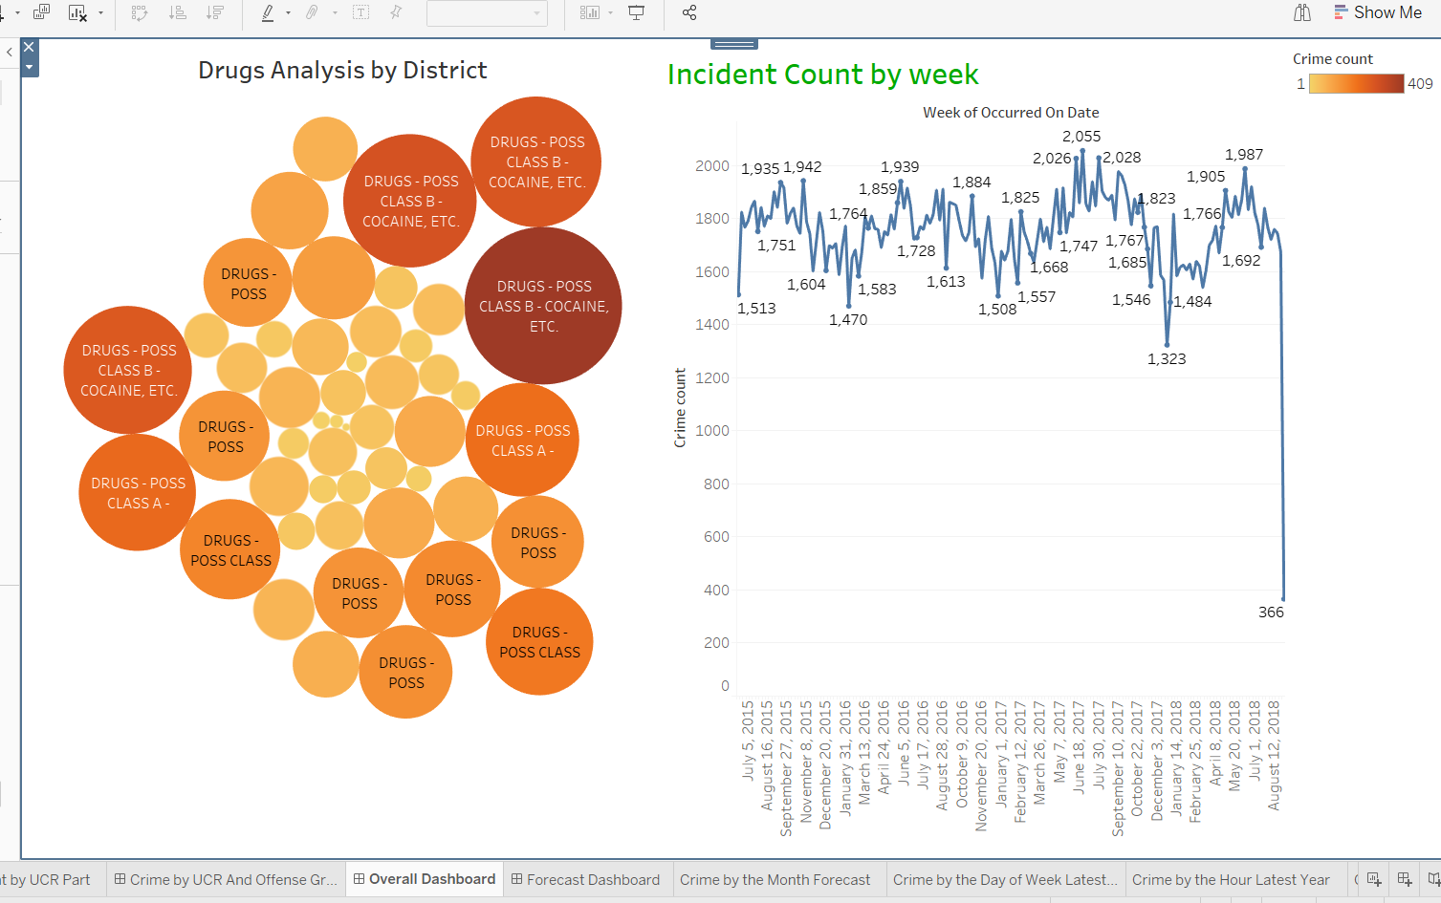

An interactive representation of the type of crime and its analysis in terms of weekly occurrences is shown above. To understand the frequency of crimes and the times and locations where they occur, we can extrapolate trends in the weekly number of crimes. An analysis of drugs by district is also provided.

*Fig 2 :*

*Overview of crimes Forecast Dash board.*

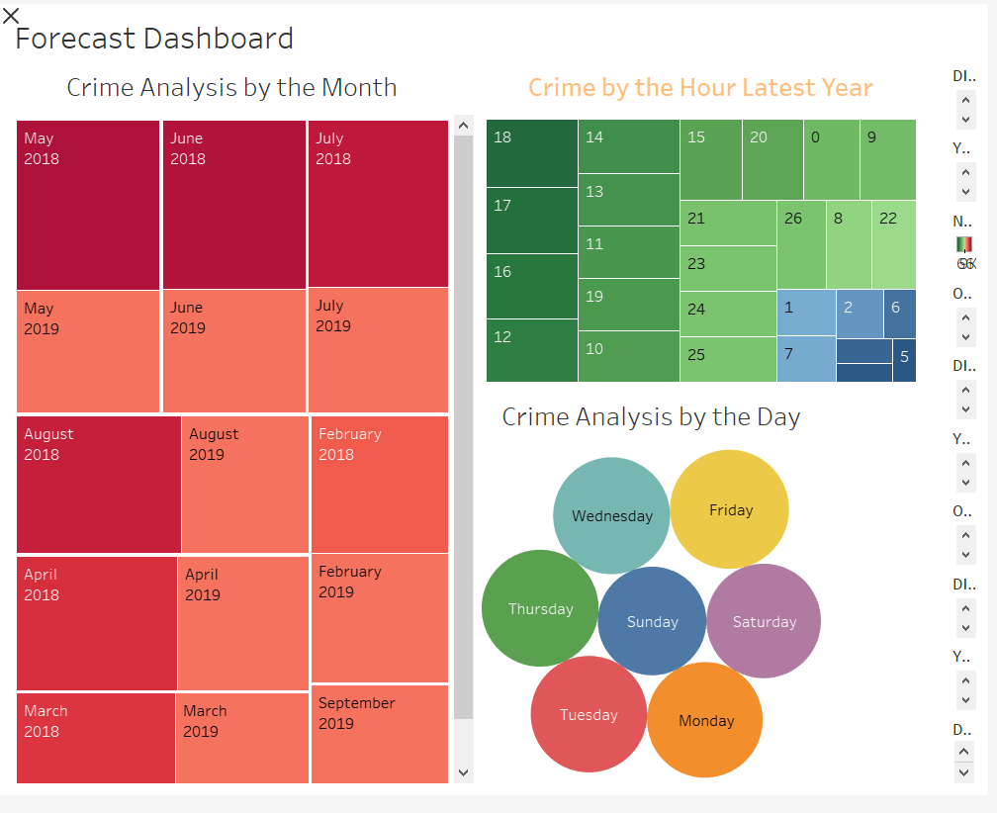

An overview of the predicted sorts of crimes for the current and following years is shown in the image above. It will aid in understanding the pattern for the current and upcoming years (next year). Based on this, they can provide the public several types of security.

Additionally, it will be delivering hourly crime counts in the appropriate areas as well as the current week's crime analysis.

*Fig 3:*

*Crimes by the Offense and Incident count by UCR Part.*

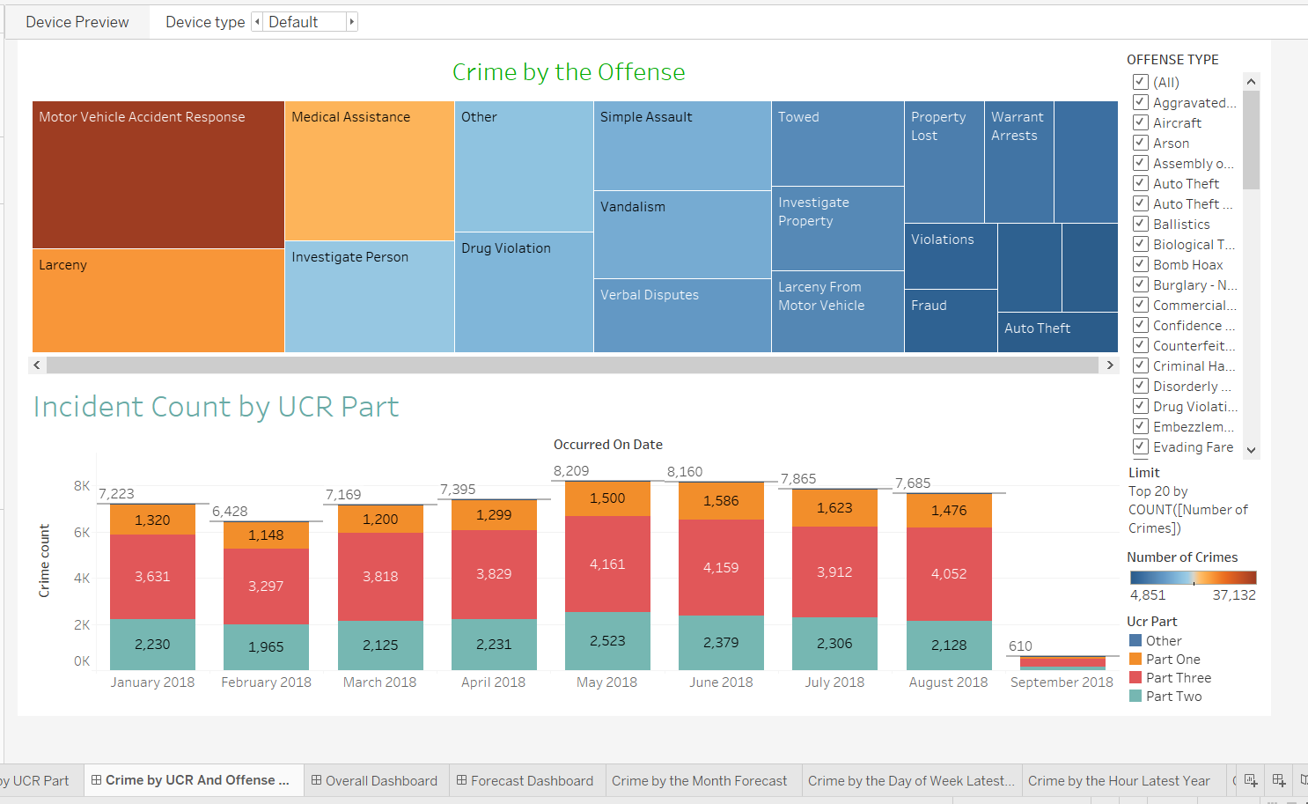

An interactive representation of the type of crime and its analysis in terms of monthly, hourly, and weekly occurrences is shown above. To determine how frequently crimes occur and when they happen, we can extrapolate trends in the number of crimes that occurred hourly, weekly, and monthly. It also gives a monthly breakdown of the number of crimes committed and identifies the months with the highest levels of criminal activity.

*Fig 4:*

*Crimes by the Offense and Incident count by UCR Part.*

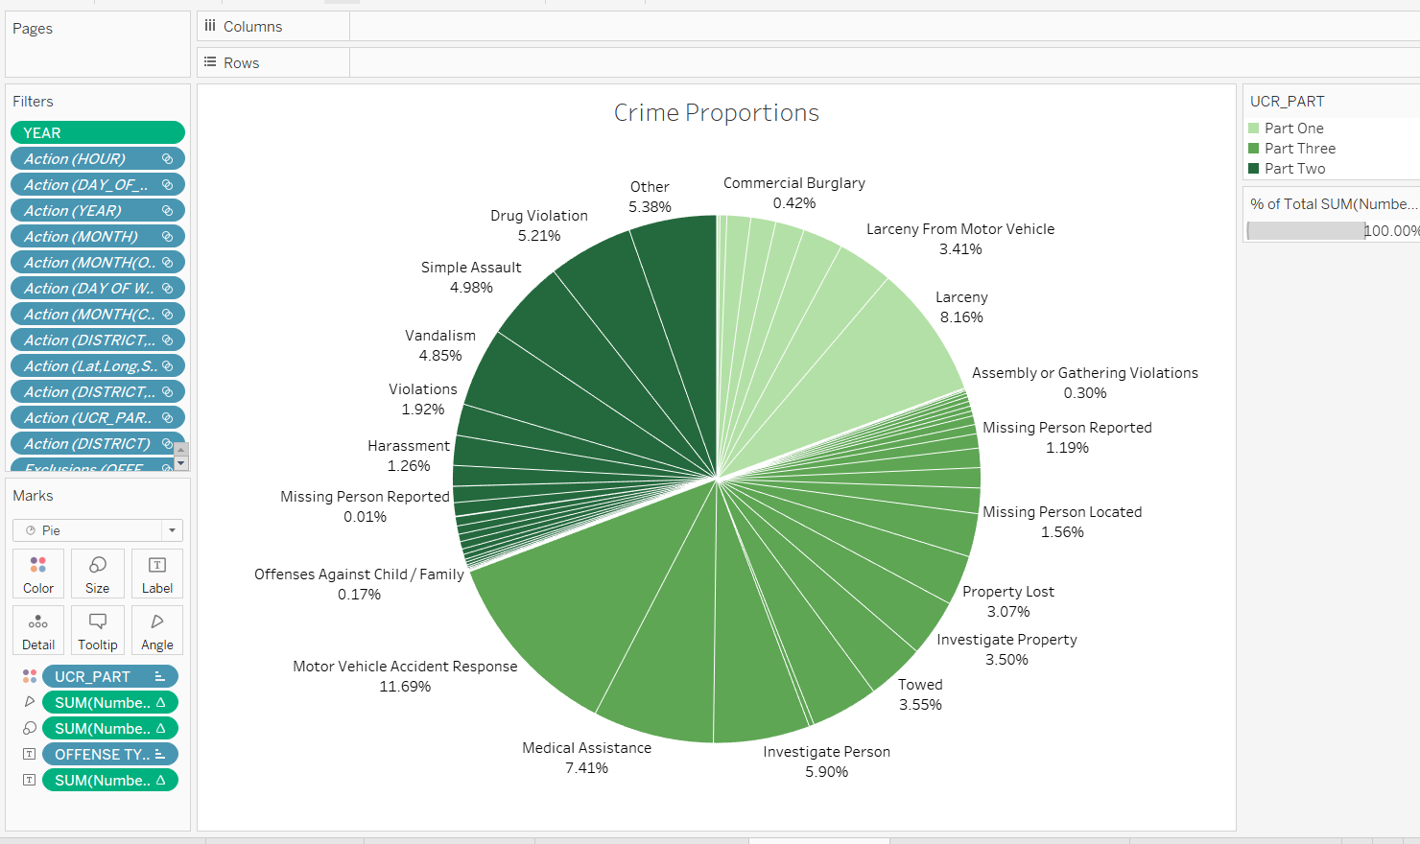

The interactive graphic above depicts the percentage of crime rates in various UCR Parts. Based on this, we may evaluate the data and assist the relevant areas in understanding the crime rate.

*Fig 5:*

*Crimes by the Offense by Week*

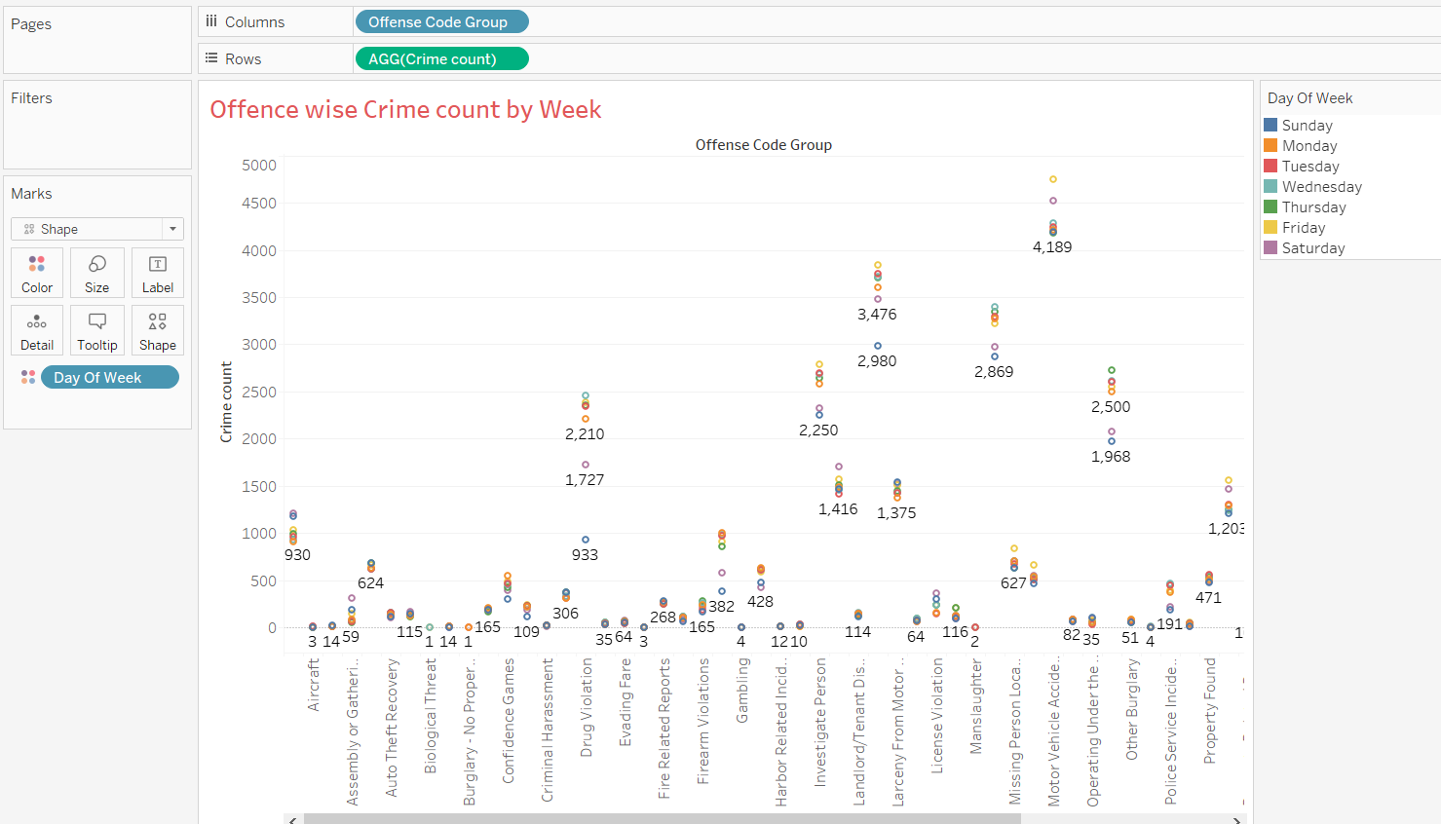

*Fig 6:*

*Street wise No of Offense Group*

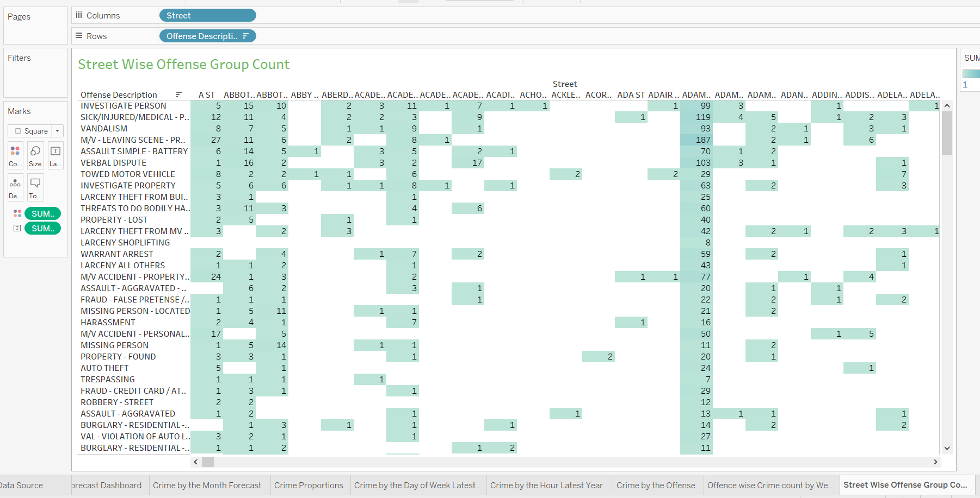

Fig 7:

# Of Heroin and Cocaine drug cases

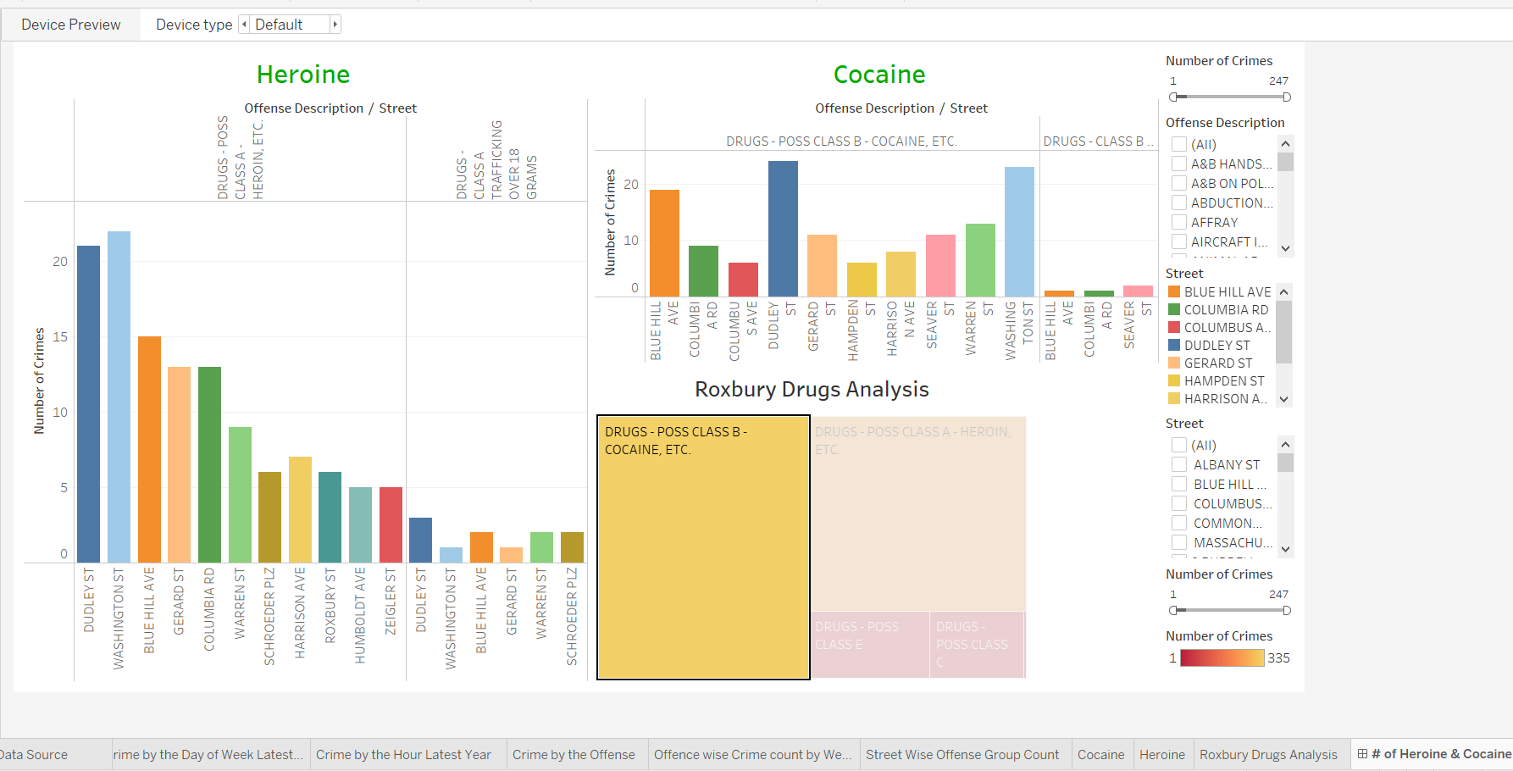

Conclusion & recommendations

Home values have traditionally been influenced by a city's crime rate since many prospective purchasers don't want to live somewhere where they might become a victim of crime. In terms of home and community safety, Boston was ranked 54th overall in the United States and in the bottom half of the list.

Boston is a very intricate town where crimes happen and aren't decreasing, according to FBI crime data.

According to our visualizations, we can see that most of crimes take place on Fridays and during the busiest times of the day. The Boston Police Department (BPD) can plan more effectively based on the segregated statistics of crimes occurring in districts because August had the highest number of crimes in Boston. The BPD patrolling schedules, active response teams, and the reduction of crime in cities will all benefit greatly from the Streetwise division of crime incidence.

Analysis also allows us to prioritize incidents and see how regional crime statistics improve district safety measures. According to the UCR (universal crime report) graphs and data, Roxbury is the district with the highest number of crimes and is experiencing an annual increase.

Our clear research and visual representations allowed us to draw the conclusion that drug trafficking in Roxbury is likely one of the main causes of the spike in crime. We were able to see how drug trafficking might affect suicides and accidents in the area and the importance of putting an end to excessive drug use.

To conclude,

The police department can profit from data visualization technology, and these benefits extend to the community at large. The likelihood of a crime being quickly solved increases when police gain a larger perspective.

Thank you!